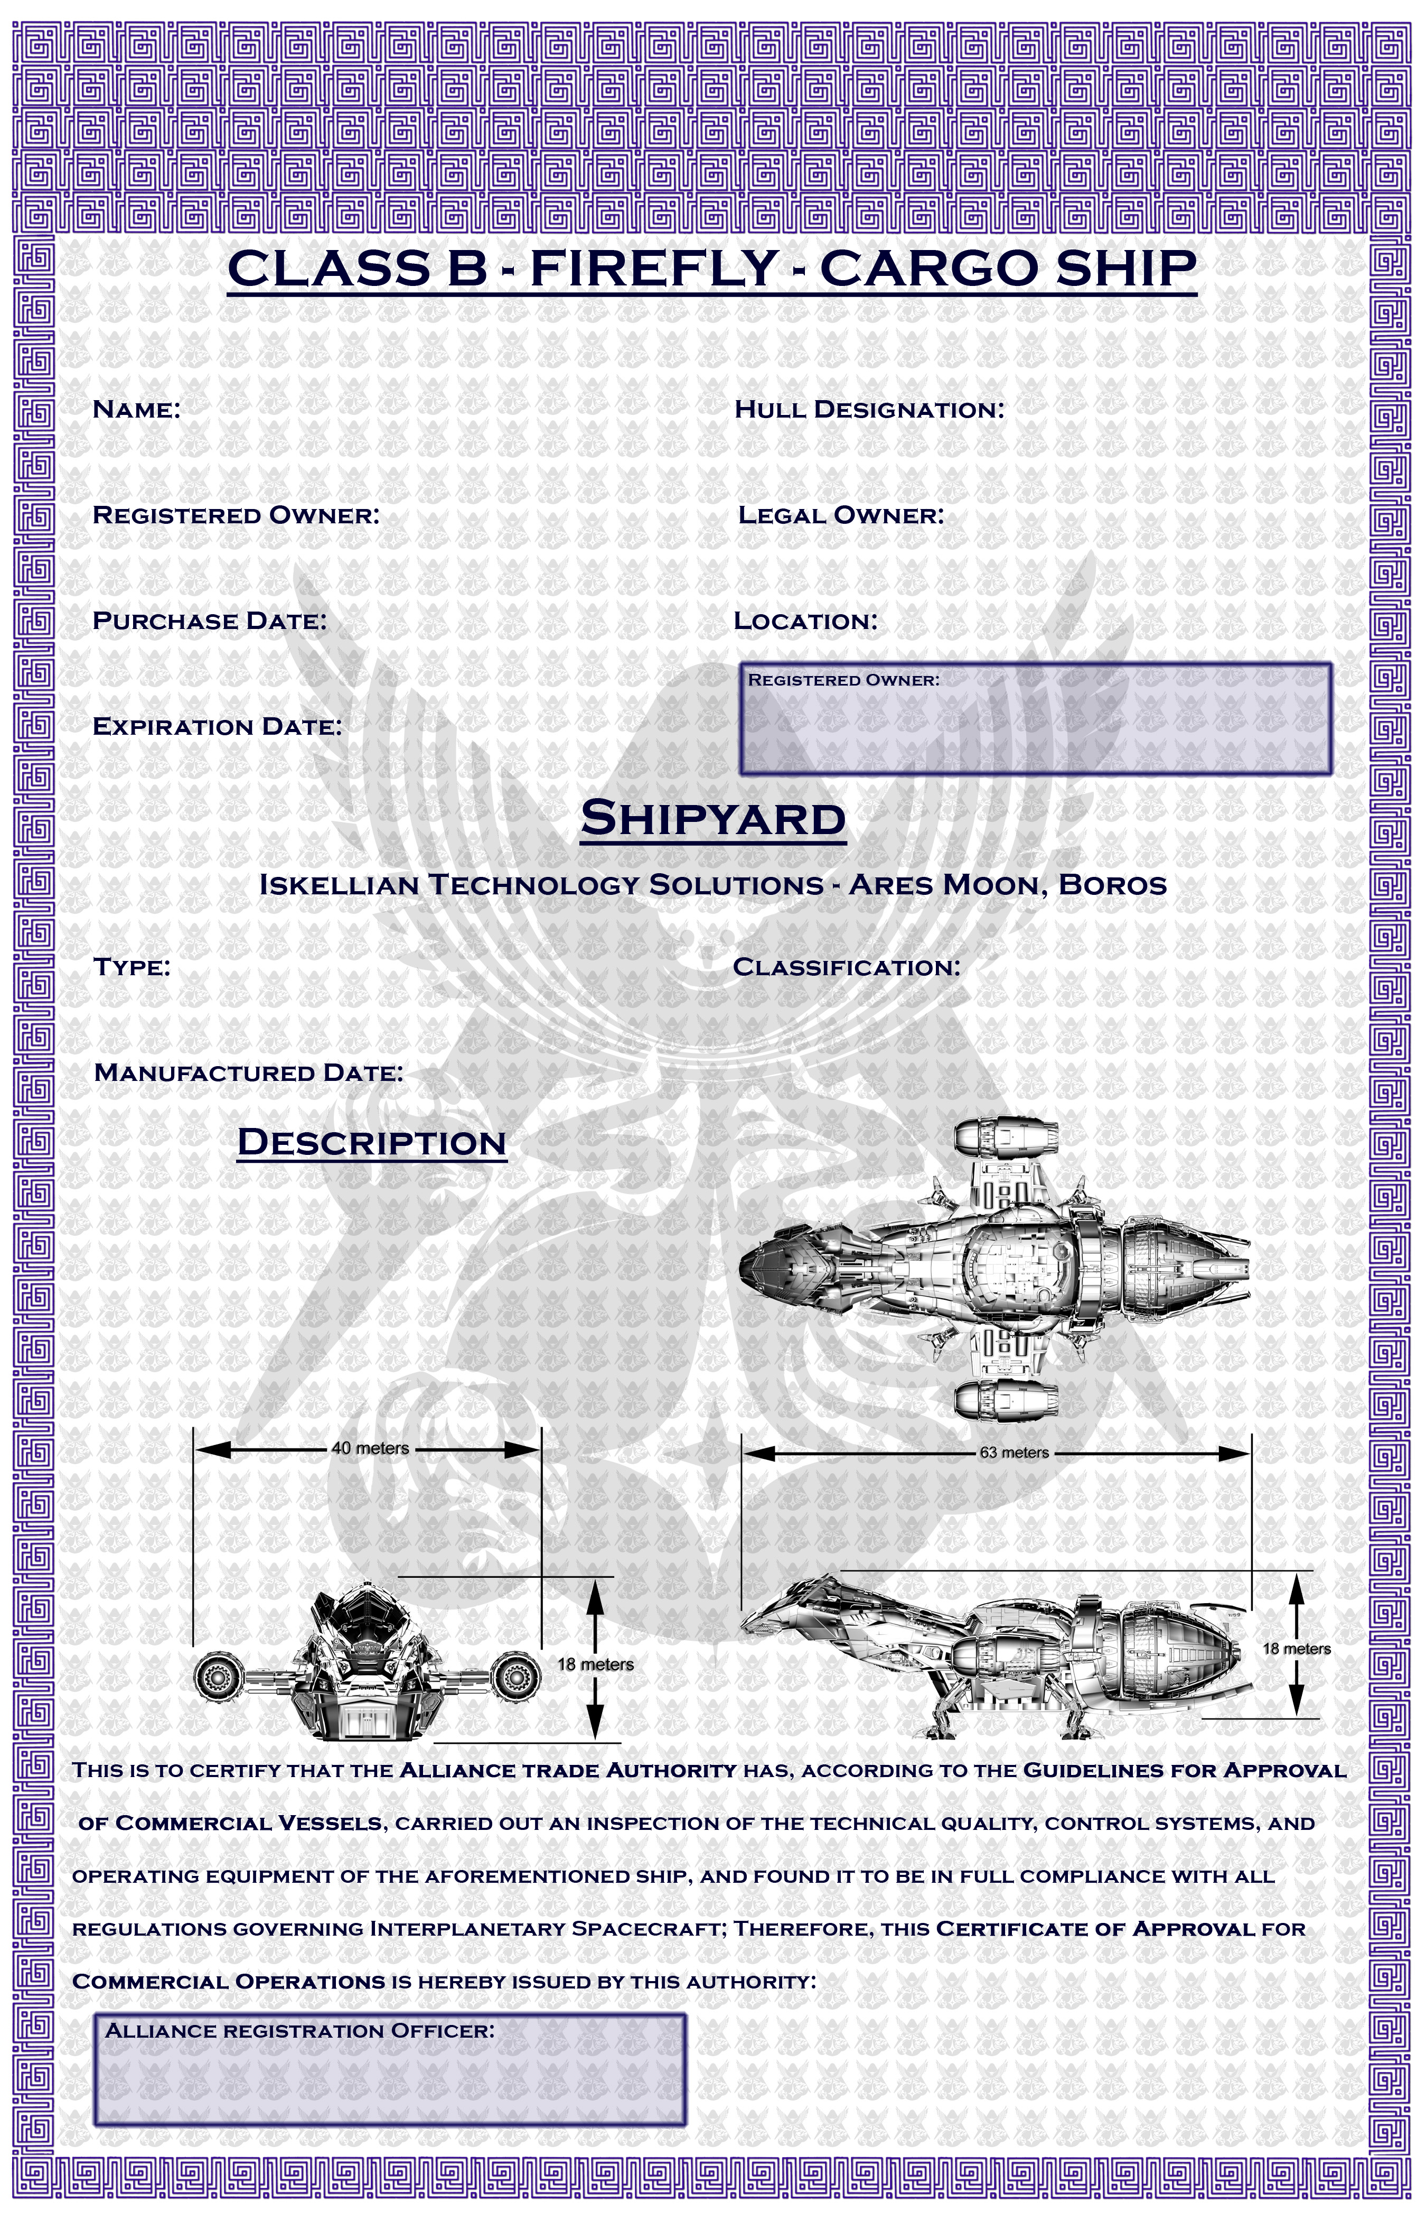

Rapscallion AMS-5K47RX2

Solomon Tango Same

April 9, 2518 Arcadia

April 9, 2523

Firefly 08-K64

August 11, 2488

2400 Ton Mid-Bulk
Transport

Brad Corbett/Brad Corbett

